**Model Development Phase Template**

|  |  |
| --- | --- |
| Date | 15 November 2024 |
| TeamID | 739909 |
| Project Name | Unlocking the Minds: Analyzing Mental Health with NLP |
| Maximum Marks | 10 Marks |

**Initial Model Training Code, Model Validation and Evaluation Report:**

The initial model training code will be showcased in the future through a screenshot. The model validation and evaluation report will include classification reports, accuracy, and confusion matrices for multiple models, presented through respective screenshots.

**Initial Model Training Code (5 Marks):**

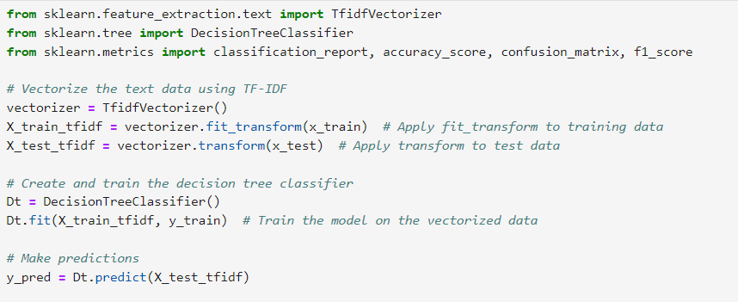

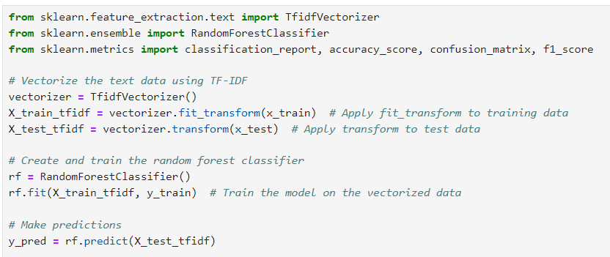

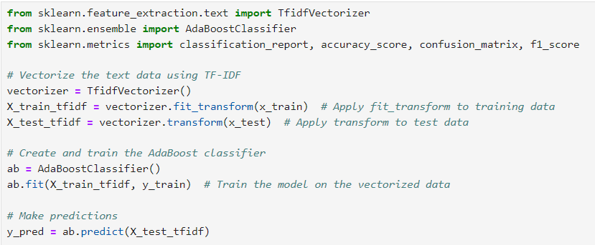

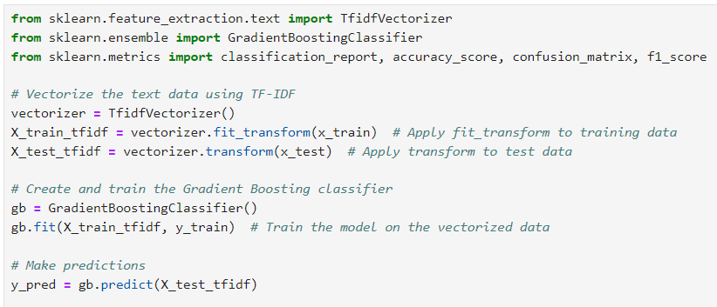

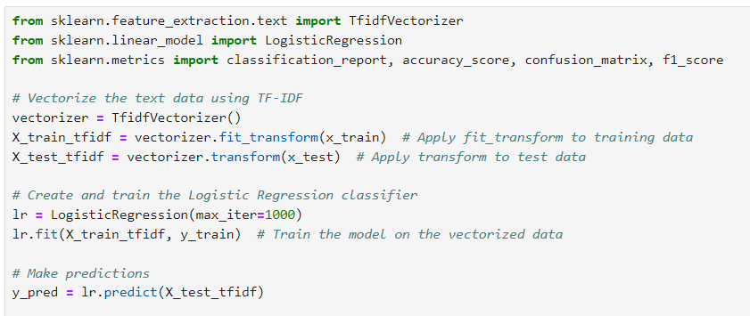

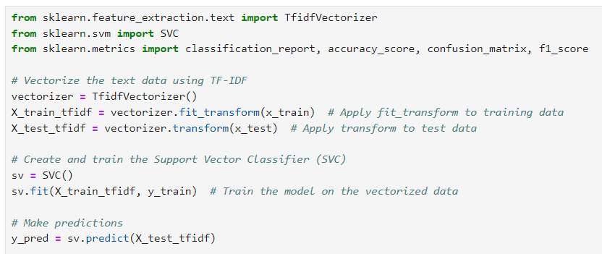

**Model Validation and Evaluation Report (5 Marks):**

|  |  |  |  |
| --- | --- | --- | --- |
| **Model** | **Classification**  **Report** | **F1 Score** | **Confusion**  **Matrix** |
| Decision Tree Classfier |  | 81% |  |
| Random Forest Classifier |  | 88% |  |
| Adaboost Classifier |  | 86% |  |
| Gradient Boosting Classifier |  | 86% |  |
| Logistic Regression |  | 91% |  |
| Support Vector Classifier |  | 92% |  |

|  |  |  |
| --- | --- | --- |
| **Model** | **Summary** | **Training and Validation Performance Metrics** |
| Decision Tree Classfier | Decision Tree Classifier is particularly useful for “Unlocking the Minds: Analyzing Mental Health with NLP” due to its interpretability and ability to handle both categorical and numerical data, making it effective for understanding key decision points. It also excels in capturing non-linear patterns, which are often present in mental health-related text data. | - |
| Random Forest Classifier | Random Forest Classifier is well-suited for “Unlocking the Minds: Analyzing Mental Health with NLP” due to its ability to handle large feature spaces efficiently and its robustness against overfitting through ensemble averaging, making it ideal for text data with complex patterns. | - |
| Adaboost Classifier | AdaBoost Classifier enhances text prediction in “Unlocking the Minds: Analyzing Mental Health with NLP” by combining weak learners into a strong model, excelling in handling imbalanced data and improving classification accuracy through adaptive boosting techniques. | - |
| Gradient Boosting Classifier | Gradient Boosting Classifier excels in mental health text analysis within “Unlocking the Minds” due to its ability to build robust models by combining weak learners, effectively capturing complex patterns in data. Its iterative approach minimizes error and enhances prediction accuracy, making it ideal for nuanced NLP tasks. | - |
| Logistic Regression | Logistic Regression is ideal for “Unlocking the Minds: Analyzing Mental Health with NLP” due to its simplicity, interpretability, and effectiveness in handling binary or multiclass text classification tasks. It leverages the sigmoid function to model probabilities, making it suitable for distinguishing subtle patterns in mental health-related text data. | - |
| Support Vector Classifier | SVM is particularly effective for mental health text analysis in “Unlocking the Minds: Analyzing Mental Health with NLP” due to its ability to handle high-dimensional textual data and classify complex patterns using kernel-based transformations. Its robustness to overfitting ensures accurate predictions, even with limited labeled data. |  |